# 1.You placed an online order for a flower vase. However, when you received it, it was damaged. Write a letter to the manager of the company. In your letter, you should:

* **Give the details about the equipment.**
* **Explain the damage.**
* **Suggest what you want the manager to do.**

##################################################################################

Dear Sir/Madam,

I am writing this letter with regards to the order #AHGT45 online from your website fnp.com on 11th July, 2003.

I opened the package and found that the flower vase is fully damaged because the same was not packed carefully. While checking online for the same product I don’t find any availability in the stock. I am looking for a replacement of this product once the stock is available. Incase there is no availability within a week, I suggest to return the product and initiate the full refund back to my source through which the payment was made

Lastly, I suggest you to kindly check the product details like color before the pacing and kindly use the fragile method for extra care of these products to avoid this issue in the future. Looking forward to hear you soon

Your Faithfully,

Hemant Chandani

##################################################################################

**2.Write a letter to your neighbor (who is also your friend) about the damage that occurs to your car while he parks his car in the space allotted to you. In the letter, you should:**

* **Describe the damage**
* **Say how you feel about this problem.**
* **Suggest on actions he should take.**

##################################################################################

Dear Mr. Aman,

I wanted to bring an attention to an issue which happened few days back right in front of my house.

We know each other as a neighbor but more as a friend from past 4 years. You hit my car and broke completely the front side of it while parking your car in the space which is allotted to you

I am frustrated but I believe this might have happened accidently. I checked the CCTV camera came to know that it happened on last Monday evening while you were returning from office.

I would appreciate if you can get this fixed or pay 3500 as a repairing cost. Additionally requesting you to be careful next time while parking the car.

Yours Sincerely,

Hemant Chandani

##################################################################################

3. Your friend recently moved to the same town where you live. Write a letter to invite your friend to go to the gym together. In your letter,

* describe why you go to this gym
* say what part of this gym you recommend
* explain why you think it is suitable for your friend

##################################################################################

Hi Nirav,

Hope you are your family doing well. I got to know that you're relocated last week nearby. I'm writing to invite you to the gym membership I recently enrolled for and have all activities for their members so let's make fun together at the field.

I'd like to recommend that you should also sign up for the basic membership as a regular member.

This will enhance your energy level and keep you fit in all aspects. it also offers discounts for students so don't forget to avail it. Additionally, it is a multi-facility gym with options for swimming and sauna. I would like you to try the steam room at the club, which is exceptional and the service in this particular location is quite friendly

I hope you accepted my offer and we'll meet you soon at the gym

Regards,

Hemant Chandani

##################################################################################

Hello,

I am writing this letter to apply for the volunteer work that is going to start at your school in the next week. My children Dharvik and Sadhna are studying in the 7 grades respectively I am good to express thought to the children that's how they would understand what I will try to teach them.

Due to this covid pandemic, I have been sitting at my home for a long time, as my company laid me off due to low work. Educate children about science was one of my dreams since I graduated.

Before I started my IT Engg. Job, I was practicing as a science teacher at Government School and rewarded one of the best teachers of the year.

I humbly request you to consider my past experience and willingness to work as free to do a contribution to society.

Yours Faithfully,

Hemant Chandani

Write a letter to your internet service provider to complain. In the letter:

- Describe the problem and why you are unhappy

- Arrange for an engineer to visit your home

- Request a reduction in your bill

Dear Sir,

I am writing this letter to register a complaint about the internet service you are providing me. I have been using Airtel internet modem for a long time, but recently it started giving me hard time with internet connectivity. This interrupts my work as I do work from home right now. Even when it is working, it is too slow, and this affected my business adversely.

I have already called your customer service department of this twice last week. Though they responded positively, the problems are not yet solved. I would like you to send an engineer to fix my problem as soon as possible, as my company wants me to do work from home, and without a good internet connection, I won't be able to begin my work.

I hope you consider my situation and do your best to solve the mess I had to face with lowering my bill for the remaining months of this year by Rs. 250 Per Month

I look forward for a prompt reply.

Yours faithfully,

Hemant Chandani

You will be graduating from university and would like to invite your family to the ceremony.

Write a letter of invitation to your parents. In the letter:

- Explain that you have completed your studies

- Give details of the event, including time, date and dress code

- Let them know how many tickets they have and who they are for

Dear Mummy and Daddy,

I’m extremely delighted to say that I passed my final semester exam with a first class. I received the results today morning, and the college announced the graduation day will be by the end of next month.

The ceremony will be held in the Auditorium and is expected to begin by 5 pm. All my friend group has decided that we would invite our parents to Traditional Indian outfits to express our culture in Canada

I have got three tickets from the event organizer, so I would like you to ask my cousin to join you for the event we have been waiting for a long time. It would be nice to see her in front of me for many days.

Thanks for joining me and let me know for further information.

Your Lovingly Son

Hemant

Some people say that now we can see films on our phones or tablets there is no need to go to the cinema other says to be fully enjoyed films need to be seen in a cinema. What is your opinion ?

###########################################################################

Technology has completely changed the way audiences watch movies. People are now able to enjoy films on their smartphones or tablet PCs. Cinema attracts people because of its big screen, surround sound, and dark room create an immersive experience that is difficult to replicate at home.

Movies in smaller screens and lack of the surround sound system on smart devices do not let people enjoy at their best, while watching the film in a theatre atmosphere on a bigger three-dimensional screen with its dim lights and hushed audience give them an immersed sense. Many prefer watching movies on cell phones or tablet computers because watching a film on such devices is more convenient. People can watch a film on their device almost instantly and whenever they like with taking breaks at their discretion. Secondly, movie lovers have the freedom to get the movie they want in a movie app

For instance, I, and most of my friends, love going to the cinema hall so as to avoid the humdrum life. Moreover, movie theatres are equipped with hi-tech machines and sound systems so that audiences can enjoy the visual and sound effects to a great extent. Furthermore, movies are more enjoyable in a theatre due to its large screen. Many people, however, like to enjoy movies in a movie theatre. The ambience of the theatre creates a totally different experience. To put it another way, viewers can be distracted from their hectic life and they can submerge themselves in the movie, accordingly.

In conclusion, while many like to enjoy watching movies on their personal gadgets, I think theatres are the best place to enjoy them to the fullest.

###########################################################################

Many people say that the only way to guarantee a good job is to complete a course of university education. Others claim that it is better to start work after school and gain experience in the world of work.

How far do you agree or disagree with the above views?

Nowadays, many people believe that education in university level is the only way to get a good job. In contrast, some people think that working after high school is better since they can obtain experience in work environment. I will outline both issues with reasons and examples.

Firstly, there are numerous reasons that can be offered to illustrate why I am in favor of working after university graduation. The primary reason being that universities teach the necessary skills and qualities required for one to excel in their work field. Secondly, getting degrees from educational institutes enables learners to apply successfully to suitable jobs. Most of the jobs require a solid academic background as well as critical thinking skills which can be earned exclusively by attending the specialized classes at university. Moreover, students in university seem to be the lack of practical experiences in working environment. Being an employee means more of responsibilities, job deadlines, etc. and there are several consequences if they show bad performances. To solve this case, internship programs and core soft skill training can be effective ways out. For example, students don't need to look for jobs after their convocation since the university does this for them. This way most of the students get a conditional offer even before they complete their graduation.

It is true that we need experiences to do better in our job, but it cannot be denied that education is more important than it. Take a teacher’s career as an example. By teaching earlier, you may have more experience than the new one who just graduated from university. But graduated university students can teach their students with better theories or concept from each material with good methods.

To sum up, people should consider that university level education is able to develop the students as an expert person in the study and it can reduce the problems will be faced in the workplace.

(322 Words)

Recent figures show an increase in violent crime among youngsters under the age of 18. Some psychologists claim that the basic reason for this is that children these days are not getting the social and emotional learning they need from parents and teachers.

To what extend do you agree or disagree with this option?

It appears that the youth crime rate in the modern world is increasing at an alarming rate. Although there may be many factors causing this issue. This position will thus be analyzed in the following paragraphs, supported by relevant examples.

Firstly, children are likely to concentrate their opinion on playing computer games, surfing the net and less motivated. Actually, the youths are changeable who are easy to manage. That’s why at home parents, at school teachers are responsible for their early knowledge which is a fundamental point in their future. Secondly, the modern education system enforces students to obtain tangible achievements, rather than ethical perspectives. Additionally, in the technology era, people, including parents are more likely to focus on smartphones, computers or TV rather than their duties to raise children properly. According to the recent survey by Govt. of India, about 65 percent of teenagers responded to games or computer games were the most inspiring for them to make crimes.

Today, most of the parents are working, so they don’t get enough time to spend with their offspring’s, due to this reason, children involve in bad companies such as consuming drugs, consequently indulge in violent crimes to fulfil their needs that they cannot demand from parents. Despite this, the family disputes also generate the violence in the youngsters. Nowadays it is known that the crime inflicted by teenagers between the age of 18 and under dramatically increased. Most psychologies argue that there is less attention which is paid to the children by their parents and tutors. For example, reports suggest that in Mexico and United States of America, the use of euphoric substances such as Drugs/Marijuana has inclined to lead to the rise in the number of registered police cases. The lack of education to parents regarding all these topics are also a contributing factor.

In conclusion, I totally agree with that point. Teacher and parents should receive all response for getting the social and emotional knowledge, which they need. With the help of that can reduce the proportion of violent crime among youngsters.

295 Words

### On a recent holiday, you lost a valuable item. Fortunately, you have travel insurance to cover the cost of anything lost.

**Write a letter to the manager of your insurance company. In your letter:**

* describe the item you lost
* explain how you lost it
* tell the insurance company what you would like them to do

Dear Sir or Madam,  
  
I am writing this letter to inform you that I have recently lost my smart watch during my holiday visit to hometown in Ranchi and this item is insured

The incident occurred when I was on a travelling in train from Bangalore to Ranchi between 14th April 2023 to 16th April 2023 when I lost my smart watch in the train.  I am not sure whether it was stolen, or I just forgot it someplace in Train. I vigorously searched for the item for m**ore than an** hour, but it was nowhere. I immediately lodged an FIR in the nearest police station and the FIR registration number is BLR-AHC57.

I am entitled to lost property coverage under travel insurance. It’s an Apple Smart Watch Series 5, hard to find due to high demand. I would like to confirm the original price of the Smart Watch as it is a new one worth over Rs. 65,000 INR, which is too much money for the mid-range. I request you to compensate me for the full amount of the Smart Watch. I am attaching a copy of the receipt with this letter.

Yours Faithfully

Hemant Chandani

Many people say that the only way to guarantee a good job is to complete a course of university education. Others claim that it is better to start work after school and gain experience in the world of work. How far do you agree or disagree with the above views?

Recently, the competition of getting a great job has increased. Many people believe that attending in a university is only one way to get a rewarding job than other people. This essay will examine both perspectives, but I am personally in favour of starting a career early, just after finishing schools.

Firstly, it is certainly true that a degree is very important for applying a perfect job. Many companies require many qualifications for a high position before hiring new employees. A graduated degree, high language proficiency level and computer skills are all required in many official jobs today. Secondly, some professional careers such as a doctor, nurse or lawyer require a certain specific knowledge and skills which cannot learn by yourself at home or practice with some experts. Attending a n university is only one way for pursuing professional jobs. On the other hand, in some line of works, a degree does not mean anything. For example, a mechanic or business workers need only value experience need only value experience and some skills which can get only practice in these works for a long time.

On the Flip Side, Academic knowledge has limited scope, but it can be fulfilled with practical knowledge in terms of experiences, lessons, and thus it is possible when one indulges himself or herself in any work. Therefore, partly it is beneficial to work after school owing to manifold reasons. Moreover, People are more likely to make a fast track to an illustrious career since they do not have to spend many years for higher education. Instead of spending many years in university, they can utilize the time to gain a wealth of experience and skills in some areas. However, they lack theoretical knowledge and cannot gain a luxury job as same as the higher-level students.

To sum up, people should consider that university level education is able to develop the students as an expert person in the study and it can reduce the problems will be faced in the workplace.

335 Words

**A number of different medical traditions are now widely known and used: Western medicine (using drugs and surgery), herbal medicine, acupuncture (using needles at certain points of the body), homoeopathy (using minute doses of poisons), and so on. How important is the patient’s mental attitude towards his/her treatment in determining the effectiveness of the treatment?**

It is certainly true that in today's world, many medical advancements have been developed and helped mankind in surviving from dangerous diseases. Health is always important for everyone, and these medical facilities are improving day by day. However, it is argued that a patient’s mental attitude towards this treatment is vital in making very effective. I too agree to the same to a great extent.

To begin with, the modern people like citizens have no effect recovery if cured by traditional medicine from the village, they feel the will be getting better and only be cured by the modern pills. In contrast, they feel their illness can be released more quickly by consuming modern pill or other kinds of modern medicine. Again, it is due to the level of trust or mental attitude they put on each kind of medication. Furthermore, Patients like old people are cured fast with the traditional medicine in the village. Additionally, Doctor-patient communication is a very important factor the patients always trust their doctor earlier and believed them they are choosing the right drugs and measurement for the remedy. In recent research in Mexico, it shows people who feel more positive and believe in themselves are cured fast with the help of medicine as compared to people who are worried about their therapy.

Looking at from another angle, the attitude of a person towards the treatment option is very crucial in the effectiveness of his treatment. Therefore, mental attitude towards medication or remedy is very much important its help a person to recover faster. For example, some people find themselves comfortable with herbal medicines, while some feel homeopathy is the best for them. In this case, another treatment option, if provided to any of these individuals is most likely to fetch negative results. By contrast, if he is provided with the treatment option he prefers, for example acupuncture to Western medicine, it would appear to be effective.

To Conclude, I admit that there are specific treatment options for specific illnesses. For instance, better treatment options for lung cancer is either chemotherapy or lung resection. Here, alternative treatment options are least effective, even if the patient favours any of those. [364 Words]

**Your car insurance company has told you that they are going to increase the amount you have to pay in insurance for your car each month. You are not happy about this.**

**Write a letter to your insurance company. In your letter explain**

* **Why you are writing to them**
* **Why you think the insurance should not be increased**
* **What you want them to do**

Dear Sir or Madam,

I am writing this letter to express my sorrow regarding additional charges for my vehicle insurance. This incremental cost would hamper my fiscal position because it would increase my expenses. Also, it would be considered as breach of contract.

I have been managing my car insurance with your company for the last 3 years and my insurance policy number is ACKO-AB12GH548A. My monthly premium is already higher than that of some of my colleagues and relatives. The 20% increase in monthly insurance payment is not acceptable because I am already paying higher, and no other insurance company has raised their premium recently.

I would request you to reconsider the decision, otherwise, I am afraid I will have to move my car insurance policy to another company or request you to revise your documents, and do not change the amount at least for the premium customers. Although I understand that you provide top-notch services to your customer, I still believe that there is no justification for increasing the amount.

I am looking forward to receiving your reply as soon as possible.  
  
Yours faithfully,  
Hemant Chandani

(189 Words)

**General IELTS Reading Test 11**

* 18
* 28
* 32
* A
* C
* E
* E
* B
* D
* C
* A
* B
* D
* B
* C
* B
* A
* B
* $68.50
* $154
* 21
* 17
* BORONIA
* WOMEN
* 1969
* 280
* D
* PRE-SECONDARY
* SUPPORTED SECONDARY
* SECONDARY
* ENGLISH
* SCIENCE
* TRUE
* NOT GIVEN
* FALSE
* NOT GIVEN
* TRUE
* FALSE
* TRUE

**General IELTS Reading Test 12**

1. E
2. B
3. D
4. A
5. D
6. C
7. R
8. E
9. R
10. E
11. R
12. R
13. BIRDSONG
14. BINOCULARS
15. TEA
16. DAMPER
17. POSSUM PROWL
18. TORCH
19. NON-SLIP SHOES
20. LOVELY
21. VII
22. IV
23. I
24. III
25. V
26. A
27. E
28. C
29. C
30. D
31. COMMUNICATION
32. C
33. C
34. D
35. A
36. B
37. D
38. FALSE
39. NOT GIVEN
40. TRUE

**General IELTS Reading Test 13**

1. 1821
2. HUNTER
3. 1870
4. A & C
5. B
6. A
7. D
8. I
9. G
10. K
11. J
12. E
13. H
14. F
15. LECTURE
16. 9
17. TUTORIAL
18. COURSE B
19. WORKSHOPS
20. $15
21. WORKSHOPS
22. D
23. A
24. F
25. C
26. B
27. YES
28. NO
29. NOT GIVEN
30. YES
31. YES
32. YES
33. NOT GIVEN
34. C
35. J
36. I
37. H
38. F
39. B

**Some people choose to eat no meat or fish. They believe that this is not only better for their own health but also benefits the world as a whole.** **Discuss this view and give your own opinion**

Nowadays, people are free to make a lot of options related to food. In my view of thinking, meat and fish are one of the most important foods for our normal health condition, so it is harmful to refuse it absolutely. In my opinion, I agree that this will bring many advantages but also causes several drawbacks.

Some people become vegetarians because they believe that this will benefit their health. To start with, people who do not consume meat or fish are termed as vegetarian, they are an important aspect of food lifecycle. Firstly, meat and fish provide a lot of useful vitamins. It is extremely necessary for our normal vital processes such us growing or maturing. Lack of this material causes serious disabilities. Secondly, meat and fish are essential for health. Both are the key source of proteins, a nutrient crucial for our muscular health. Furthermore, fish intake is particularly important for pregnant and breastfeeding women and people during childhood. I therefore, believe that a moderate intake of meat and fish is of profound importance. For example, the Belgium Society of Community Nutrition recommends that people should intake three weekly servings of meat and fish.

On the other hand, there is an opposite effect with an increase of a vegetarianism trend, the pressure on agricultural production. In addition, there are many other healthy food items available that are rich in proteins and other vitamins. The fact is that every year, the food processing industry consumes a large amount of clean water to produce meat or beef and release tons of waste and smoke to the environment. Furthermore, the government should put a ban on all flesh products and stop importing or exporting these items. Proteins help us to be stronger and are very important to the growth of the children. The reduction of meat consumption leads to the protection of the environment and save the ecosystem. For example, as per the World Health Organization report in 2011, over 63% of animals were killed in South Africa to fulfil meat appetite of only 27% of the local population

In conclusion, although avoiding meat and fish is vital not just for healthy living but for the environment also. These foods should be eaten because they remain the best source of proteins and that is why moderately eating them is a healthy choice **(391 Words)**

**In many countries, people are concerned about the number of children who are overweight. What do you think are the causes of this? What solutions can you suggest?**

It is true that there is a growing trend of obese children in industrialized nations in recent years. While this issue is being attributed to the growing number fast food restaurants, I would argue that parents should take some responsibility as well

Firstly, there has been a large increase in health-related diseases amongst children, especially diabetes. This debilitating illness means a child has to be injected with insulin for the rest of their life. Secondly Not only this, very overweight children often experience bullying from other children, which may affect their mental health. The negative stigma of being overweight may also affect self-esteem. Moreover, raising realisation of a balanced diet and giving encouragement to students to eat vegetables and fruits are also of great importance to tackle the problem. In addition, with the significant proliferation of fast-food restaurants, this unhealthy food is consumed on a regular basic so that the adolescents are at risk of being overweight. The situation could be rectified by banning fast food in places such as schools and restaurant. For Example, parents are expected to keep an eye on their children's eating habit and make sure they take healthy food while reducing the quantity of luring junk food. Government can contribute by putting a ban on unhealthy items specially prepared keeping in mind to children.

Furthermore, the rise in obesity of teenagers can be attributed to the lack of exercise. Recently, children are required to work and do well academically so that they hardly have sufficient time to do outdoor physical activities. They devote a great deal of time to doing the academic work. For this reason, children are always pressed for time and tend not to have some workout. Additionally, with the advent of technology, playing on computers and watching television are growing in popularity rather than playing outdoor sports and doing exercise. A useful suggestion would be to increase the time for sports and outdoor activities between lessons to promote the students' well-being. The amount of homework and revisions should be reduced for the sake of adolescents' health

To summary, overweightness is a concerning issue in many countries. Thus, solutions to this are necessary and essential because health is one of the determining factors in people's lifespan. Everyone should be aware of their health.

**[380 Words]**

**Is freedom of speech necessary in a free society?**

Human beings have an unquestionable need to express themselves and their needs through various forms, the most common of which is speech. Therefore, the freedom of speech is of vital importance for a society to be called “free”.

On one hand, it has been heavily debated that freedom of speech can be dangerous. This is an extremely understandable position, and one that is applicable to many countries. To Start with, Freedom of speaking is necessary for anyone either he is 2 years old kid or 60 years old man. It gives people courage to communicate to make decisions and work on that. Secondly, some people may argue that even free societies have laws to protect people from harmful. however, speech is not an action. In other words, even hardest words harm nothing. Thirdly The tolerance of the ruling authority to accept opposing viewpoints possibly create a democratic atmosphere in political life of a country promoting social development. For Example, Politician speak in public places to make the commitments and plans to develop the country. Audience listens to them patiently, analyse their words and gives approval in the form of vote to win, so that he can get a chance to work on his promises and commitments.

On the other hand, constructive criticism is the only way for civilization to move forward. Dictatorships that suppress the opinion of the common man can be problematic to the rulers themselves. It prevents any opportunity for people to support the people in power, and, after enough time has passed, it can lead to civilians rioting against these rulers. For example, the Greek movement in the early 60's started talking about black people's rights, which eventually led to a fundamental change in the government's approach towards black people. If the right of speech is not there, people never speak out against authority in fear of punishment. and the wrong policies never got corrected. some believe that freedom of speech can result in the debate on even small things and that's apparently true.

To recapitulate, while it is essential for the societies to have the required flexibility in hearing the folks’ notions about the current affairs without censorship, some controls are also needed to prevent the devastating flood of the data.

**[381 Words]**

<https://ieltsonlinetests.com/ielts-mock-test-2023-january-reading-practice-test-1?passage=1>

1. obscure
2. 793
3. Northwest Africa
4. local populations
5. monotheistic religious
6. F
7. D
8. E
9. A
10. G
11. B
12. C
13. D
14. H
15. Yes
16. No
17. Yes
18. No
19. No
20. Not Given
21. temperature
22. rock
23. food production
24. wave
25. ice age
26. rockets
27. D
28. D
29. G
30. F
31. A
32. E
33. B
34. C
35. Not Given
36. False
37. True
38. True
39. True
40. Not Given

**In many countries, the proportion of older people is steadily increasing.**

**Does this trend have more positive effects or negative effects on society?**

In recent years, there is a significant increase in the proportion of elderly people in many countries. My essay will analyse both because I think that this trend has both positive and negative effects on society.

Firstly, Older adults have been appreciated as the valuable and essential resource to their communities with material and immaterial contributions which benefit the younger. The increased longevity might create many time opportunities for those who still eager to pursue their working or researching passion for societal development, encouraging the young generations to inherit and attempt more for further success. Secondly, older people are more experienced and can contribute largely by counselling the young generation. There are some professions like teaching where an experienced teacher can be more benevolent than a young teacher. Additionally, since young members of a family are busy outside and cannot manage time to share with kids, so the older people can be good companions to those kids and can help them to raise in a family environment rather than in a day-care- centre. For Example, Most Sweden women work, but less than half work full-time. Using this resource would increase the status of women in the society.

On the contrary, the more people retire, the heavier pension burden the state must carry. After a certain period for working, whether their living standards are better, they still have right to receive social welfare from their government. Older people require more attention and extra care and the touch of relatives. But because of generation gap and poverty, they are often ignored and that's a horrible experience for them. As the medication and health facilities improve, the mortality rate of the country also increases, and it would cause a serious population problem for the country. On the other hand, compared with the negative impacts that ageing populations would have on economic activities in other industries, the possible growth in healthcare-related jobs would seem insignificant.

Considering all the issues, though it might seem little harsh, but I think that a considerable portion of older people can be helpful for all of us but if it's reach to an extreme proportion then it's a bad omen both for the new generation and the old people themselves.

**[370 Words]**

**Many old buildings protected by law are part of a nation’s history. Some people think they should be knocked down and replaced by news ones.**

**Do you agree or disagree?**

A group of people believe that protecting these old buildings is considered as a waste of money, as they should be demolished and replaced with new buildings. I personally believe that maintaining an old building is essential, since the building has a lot of historical values, and it would be unique to see cities that combined the modern and historical buildings together.

To commence with, many buildings serve the purpose of emotional memories to a vast population. There are many constructions in which they make future generations attached to their ancestors. The heritage will remind us of the sacrifice and struggles that our elders have gone through for us to live a privileged life. Secondly, many of the buildings had become the witnesses of some special or tragic moments of a particular country, therefore it should be preserved. Additionally, Some cities are still protecting their historical buildings, though new high rise buildings are showing up in the surrounding area. The historical buildings are maintained by the state government, and they are standing along with the new skyscrapers. One of the examples would be the Taj Mahal which is one of the Seven wonders of world in Agra, India. It is an old building that was erected during the Mughal Emperor 16th century. Now, it is maintained by the Government as a India and mandate as tourist place

On the other hand, the government of laws are supporting with protection older buildings. But some people view they should be destroyed and exchange with new ones. For instance, the old building is changed a necessary to places such as hotels and house. Thus, the old buildings are changed to profits existing for people. In addition, although history should definitely be remembered and respected by the citizen of the country, it should not stand in the progress. This is since it has happened in the past and the country should always be looking forward to grow.

In conclusion, it is incredibly advantageous to provide laws to protect historical buildings, since it will provide past information and contribute to the country's GDP. Nevertheless, the nation should not let history to stand in the progress, because it will prevent them to be more advanced in the future.

**[372 Words]**

**Some people believe that excessive use of modern technologies, such as computers and smartphones, is negatively affecting the reading and writing skills of our young people. To what extent do you agree or disagree?**

Some people believe that technology adversely influences our lives and its manipulating aspects take control of our lifestyle. Others, however, hold the view that technology has many benefits to offer to humankind. This essay discusses both views. However, I think that technology will be advantageous as long as we control it, and do not let it control us.

Firstly, Young people who spend a lot of time playing with their phones and computers are likely to have insufficient time for reading activities. Gradually, the lack of practice may impair their reading competence in the long term. Secondly, Mobile phones have improved noticeably in terms of performance and usefulness. Nowadays, they are being used in every aspect of life including paying bills, making contacts, taking notes, surfing the internet and for many other practical purposes. The modern world is indeed defined by modern technologies. However, In terms of writing skill, modern people do not handwrite often since they can talk using their smartphones which is more time-efficient and easy to communicate. Therefore, young people’s reading and writing skills decline. For Example, If young people use these devices, they do not pay attention to making correct sentences and selecting appropriate words which brings them to write sentences without having correct grammar and vocabulary.

On the other hand, Technology does not come without negative consequences. It has already started controlling many of our daily life aspects and can get more catastrophic than anyone could even imagine if it gets out of control. Additionally, It is pretty easy for hackers to hack into someone's phone and misuse them. Online transaction fraud, malicious viruses and trojans, health hazards, and a lack of personal and social bonding are thus attributed to our inclination towards technology. Moreover, Easy and instant access to videos and movies pushes books further down the list of preferences of young audience, and it takes a significant commitment from parents and teachers to ensure that children continue to read books. For example, everybody is using cellular devices these days, so they store their personal photos, contact details and even files on their phones.

In conclusion, the views regarding the impact of technology on our lives are divided. In my belief, it is essential to be mindful of the pervasive presence of technology and take proactive steps to maintain a healthy balance between the digital world and real-life interactions.

**[395 Words]**

**The economic development plays a major role in people’s lives. Economic growth in both developed and developing countries make the country richer, but it is believed that people in developing countries are happier that those in developed ones. Do you agree or disagree?**

The world economy has improved significantly in the past few years and made several people become wealthier in both advanced and developing countries. By looking at this case, I personally believe that happiness is not only about money but there are some factors involved to gain it in this life. This essay will look into the reasons with some prons and cons.

Firstly, a healthy economy results in job creation, a high level of employment, and better salaries for all citizens. Secondly, economic progress ensures that more money is available for governments to spend on infrastructure and public services. Moreover, they now face stiff competition from their counterparts in the developing countries. Their market share has started eroding. They are no longer the most sought after candidates for jobs even in their own countries. For example, a government with higher revenues can invest in the country's transport network, its education system, and its hospitals. Finally, a strong economy can help a country’s standing on the global stage, in terms of its political influence and trading power.

On the other hand, economic growth has a different meaning for people in the developed world. Majority of people in the developed world already lead comfortable lives. They are no longer the most sought-after candidates for jobs even in their own countries. Worse still, more and more jobs now get outsourced to the developing world, where the cost of labour is low compared to that in the West. As a result of this people in the developed world are now losing their jobs. They aren't all that happy with this sudden spurt in global economy. To illustrate, companies specializing in technology must regularly update the market situation to attract customers by creating new designs and technologies.

In conclusion, the theory of “economy cycle” driven by business cycle theory is inevitable arguing that a country who has reached the maximum outcomes in economy, will suffer a daunt fall whether it will be significant or steady is based on the effective efforts by the country.

**[301 Words]**

**A large company in your area has decided to spend a certain amount of money, either to sponsor a local children’s sports team for two years, or to pay for two open-air concerts. It has asked for feedback from the general public.**

**Write a letter to the company. In your letter,**

* **Describe the benefits of sponsoring the sports team**
* **Summarise the benefits of paying for the concerts**
* **Say how you think the company should spend the money**

Dear Sir or Madam,

I am writing to provide my feedback regarding your decision to sponsor a children's sports team or pay for two open-air concerts in my area. I have been living in this area for more than 20 years and this is the first time that someone as big as your company is offering to do something huge like this. To begin with, there are various advantages of sponsoring the sports team

On the first hand, Sponsoring the local team for two years will really benefit the young players as they will have a chance to be trained by professional soccer coaches. Moreover, such sponsorship will enhance brand awareness of your corporate image in the industry too. On the other hand, there are certain benefits of paying for live concerts. People get a chance to relax by listening to the soothing music performed in concerts

Finally, both sports and music are essential for healthy lifestyle. I am positive that either of your initiatives will serve our community greatly. However, supporting the local sports team has a more eminent result than escalating the music fans by sponsoring concerts. I believe that the Concerts would be temporary entertainments for the local people, but provision for the young sportsmen will be remembered for a long and would give us many occasions to celebrate and be proud of.

Hoping that you will consider my suggestion but thanks for a commendable initiative

Yours Faithfully,

Hemant Chandani

**[243 Words]**

**You have lost an item of value on a train. Write a letter to the railway company. In your letter,**

* **Describe the item**
* **Explain where and when you left it**
* **Say what action you would like the company to take**

Dear Sir or Madam,

I am writing this letter to get help with finding my costly watch that I lost on my last journey on your train. It was a watch from FastTrack brand and I bought it for 17,000 INR. I deeply regret this unfortunate event and I am looking for your help in finding it out.

Yesterday, I was traveling from Bangalore to New Delhi Railway Station at around 2.30 pm when I forgot to collect pick it and left the train. As I was very anxious to leave, I did not have time to check all the compartments while I was grabbing my belongings. I was in second compartment in moving direction and must have placed it under a seat A3-24 of the Second AC just when I arrived at New Delhi Railway Station. It is in Black and red colour digital watch with a square shaped dial and a rubber strap. It shows both IST and GMT time. The ticket's PDF is attached in the end of this e-mail so that you can confirm my information.

Please take necessary action as soon as possible as the event just happened and there are high chances that I may get my watch back. If found, please call on +91-9740493326 or send it via courier to the address that’s tagged to it

Yours faithfully,

Hemant Chandani

**[227 Words]**

**Dear George,**

**These past few days and weeks were amazing! My time in your beautiful family went by so quickly and I just do not realize that my stay in England has come to an end already.**

**I wanted to take some time to write a letter to tell how grateful I am for everything you have done for me and my family. Opening your home to a total stranger family may be scary and I thank you for trusting me and making me feel as if I was one of yours. Arriving in Switzerland with my family was not easy but you helped me and made me feel less homesick and stressed. Thank you for all the things you taught me and the advice you gave me. You allowed me to live the Swiss life I wanted to experience once in my lifetime.**

**I will forever be grateful and thankful for the moments we spent together, the amazing memories I’m carrying back to my home country and the excellent dishes you cooked. Thank you for hospitality, for the time you took to know me and for opening to me like you did.**

**I will never forget you and all the things we have shared together and learned about each other. I hope we will stay in touch and that we will get the opportunity to reunite soon. You’re welcome in India at any time.**

**Warm Regards,**

**Hemant Chandani**

**[239 Words]**

**Today’s fresh food like vegetables or fruits travels thousands of miles from the rural areas or farms before it reaches customers in cities or urban areas.**

**Why is this? Is this a positive or negative trend?**

Consumers especially those living in metropolitan and urban areas would usually spend much time waiting for fresh food which is transported from remote rural places or plantations. In my opinion, there are many reasons for the long distance of fresh food grown in farms and this phenomenon could lead to many harmful impacts on customers and farmers.

To start with, an obvious reason is the increasing demand for fresh fruits and vegetables in cities. In urban areas, people are unable to find places where they can purchase fresh food products and hence, they demand fresh fruits or vegetables. Secondly, there is no denying that delivering food from remote farms is likely to be caused by both the national polices and the public’s demand. To decrease noticeable pressure in megacities, governments tend to enter some policies to encourage citizens to migrate and build the rural areas. Additionally, Soil in the cities and urban areas are unviable compared to that of rural areas in which the fresh fruits and vegetables that are cultivated in urban areas are much healthier and more nutritious. As per last research conducted by World health organisation at Harvard University concluded that grapes and banana grown in a specific village have 73% more nutritious value than it is grown in the city Area. So Overall exporting fresh food from rural areas ensures good health.

On the other Side, if we see economically which can led to scarcity of food in some areas and because of frozen or extremely scorching weather the crop failures are predictable which can leave to a skyrocketing price. Additionally, there are high chance of fruit or vegetables are going to get squished because of long-distance drive and by the end people are going to products that are not good in quality. I read somewhere that we throw 20 tons of food approximately on an everyday basis which is a lot. So, if people start eating only locally grown food, then their choices will be limited.

In Conclusion, I strongly hold onto the view that more gains than where the food transportation from remote places to cities have no positive benefit although there are various reasons why agricultural food is usually grown in the remote places

**[371 Words]**

**IELTS Test**

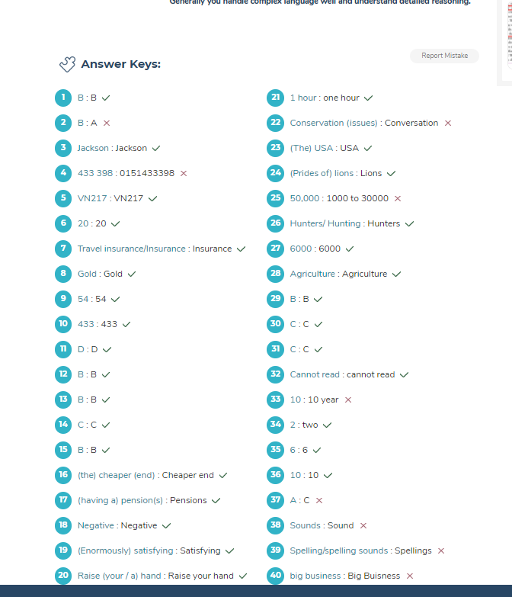

# IELTS Mock Test 2023 May Writing Practice Test 4,

# Link: <https://ieltsonlinetests.com/ielts-mock-test-2023-may-writing-practice-test-4>

The graph below gives information about the price of bananas in four countries between 1994 and 2004.

Write a report for a university, lecturer describing the information shown below.

Summarise the information by selecting and reporting the main features and make comparisons where relevant.

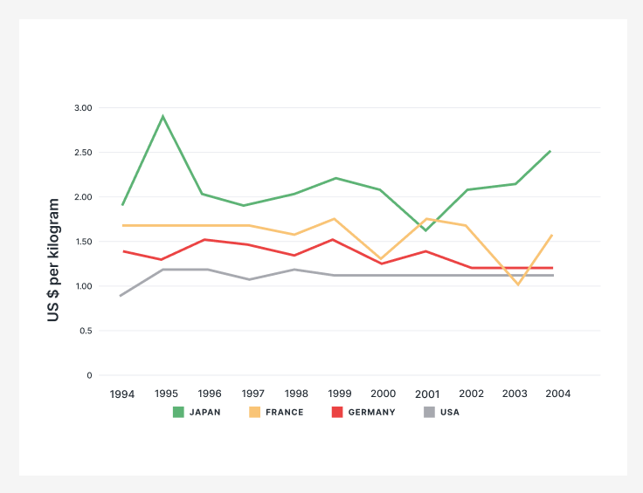

The line graph shows how much bananas cost in four different nations from 1994 to 2004. The total import figures for bananas in USD per kg for the period between 1996 and 2004 for four countries. Those are the USA, Japan, France and Germany, as shown in a line chart.

At Start what we see that that in 1996, the bananas were sold at similar prices in Japan and France amounting to 2 USD/kg. There was no change saw in the price of bananas for a next one and half year in France, but the price was inclined to 3 USD/kg in Japan in the same period, but it declined to 1.5 USD/kg and 2 USD/ kg respectively in 1999. Cost of bananas fluctuated till the end and accounted for 2.5 USD/kg in Japan and 2 USD/kg in France in 2004. However, Bananas in the USA were initially priced at about 0.7 US dollars. This was followed by a rise to approximately 1.1 one year later and a levelling off towards the end of the timeframe.

Furthermore, with Germany and the USA, 1.5 USD/kg cost was recorded in Germany that was .5 USD/kg higher than the price of bananas in the USA in 1996. Price was risen by .25USD/kg in both countries in 1998. The cost remained stable in the USA at 1.25USD/kg from 1999 to 2004, but price grew slightly to 2 USD/kg in 2002 in Germany before dropping to 1.75 USD/kg in 2004. The USA imported the least among the four countries despite a small upward trend, while Japan imported the most. France remained stable throughout the period, and Germany had a marginal increase. Overall, it is apparent that for most of the period, the price of bananas was very high in Japan, whereas the least the price was in the USA.

In conclusion, the line chart demonstrates that the price of bananas in Japan was the highest among the four nations. It is high throughout the eight-year period, while the USA had the least expensive bananas. **[348 Words]**

**IELTS MOCK 5:**

**Listening Task**

1. **Elsinore**
2. **77896245**
3. **waiter**
4. **baseball coach**
5. **rescue diver**
6. **diving experience**
7. **October**
8. **Saturday mornings**
9. **6 (o’clock)**
10. **radio**
11. **B**
12. **C**
13. **B**
14. **A**
15. **C**
16. **A**
17. **B**
18. **B**
19. **A**
20. **A**
21. **C**
22. **B**
23. **B**
24. **D**
25. **F**
26. **G**
27. **E**
28. **C**
29. **A**
30. **B**
31. **nervous**
32. **a gift**
33. **last**
34. **well organised**
35. **paying attention**
36. **sheet of paper**
37. **full**
38. **1 or 2**
39. **time**
40. **remember**

**Reading Task**

1. **E**
2. **B**
3. **F**
4. **B**
5. **A**
6. **C**
7. **A**
8. **True**
9. **False**
10. **Not Given**
11. **True**
12. **Not Given**
13. **False**
14. **True**
15. **Confidence**
16. **Website**
17. **Responsibilities**
18. **Charity**
19. **Ambitions**
20. **Gaps**
21. **Salary**
22. **Competitors**
23. **Delivery**
24. **Premises**
25. **Law**
26. **Costs**
27. **Funding**
28. **V**
29. **IX**
30. **III**
31. **VI**
32. **I**
33. **VIII**
34. **C**
35. **A**
36. **C**
37. **Energy**
38. **Dog**
39. **Vision**
40. **Ears**

**Writing Task**

**You invite a friend for some time in a month. But that is not a convenient time for visiting.**

**Write a letter to your friend to invite you on another date.**

**● write the reason**

**● apologize**

**● suggest another day**

Dear friend,

I hope everything is going well for you. I am overjoyed to learn that you will be visiting us next month. First of all, please accept my warmest.

But I regret to inform you that I will not be available in the next month due to urgent client requirement which needs to deliver the Project in Canada. I cannot say no to the client as this is my first project and I am the only available SPOC to be present who can discuss the requirements with them. Hence, we have to postpone our plan to next month or may be for some other time. Sincere apologies for changing the plan. It would be best if we meet once I return from this business trip by the 27th of April 2023. Anyway, if you're available in May? It is my Office break, and we can meet at my house. We will plan an unforgettable time together at that time.

Please let me know if you are free during that time and I again regret not being able to meet. Hope you will understand my situation.

Looking forward to meeting you soon.

Yours sincerely,

Hemant Chandani

**[198 Words]**

**Some people say that international sporting events contribute greatly to peace and stability in the world. To what extent do you agree or disagree?**

Some sets of people think that Global games play an essential role to make worlds peace and unity. I completely agree with the statement. This is essay will explain the supporting view how Global games bring togetherness and treasure in the global.

To Embark on, when a nation hosts a major sports competition the many authorities from other countries come forward to support the host. While I concede that most of the expenses are borne by the host country where financial aids from foreign governments provide a boost to event preparations. Secondly, Sports played at an intercontinental level among the countries will help in building a healthy competition spirit and enthusiasm feeling of brotherhood among the people of different countries. Denizens of various nations come close to each other, have a friendly discussion and sharing of jokes among themselves. Finally, these events attract a lot of international tourists and if they are treated well, it will improve the relationships of their country with the host country. For example, India and Pakistan though have a lot of tension at their borders, but the friendly cricket match between them helps a lot as the players play in peace and harmony as well as it serves as a binding factor within them.

On the Other Side, A peaceful environment and hospitality would be promoted through international sporting ceremonies and events, where people gathered and shared unity and patriotism to support their own countries. Additionally, we cannot refuse the fact that it gives immense joy when the spirit of the game overcomes the petty barriers of countries and cultures because national teams often have players from different ethnicities and backgrounds. This helps to spread the message of oneness and unity in diversity. Furthermore, due to such, events many nations can build healthy relationships which is important for the prosperity and growth of the country. For example, scheduled cricket tournaments between two countries like Sri Lanka or Pakistan, not only for the practice or warmup matches but also create a good relationship among the leaders. That can be later used for the development of the country or at the time of assistance.

To conclude, not only do such events improve relations between countries when they show support to each other. It also sweetens the relation between citizens of different countries. Therefore, I strongly believe that international sporting events promote peace and brotherhood.

**[380 Words]**

**Many people prefer to watch foreign films than locally produced films. Why could this be? Should governments give more financial support to local film industries?**

In many countries, especially in developing countries, foreign movies are more popular than the locally made films. There are several reasons for this trend and the government can and should greatly contribute to promoting domestic movies for the overall progress of the industry.

To begin, a problem with a small number of viewers of locally produced films perhaps due to their not professional makers. In other words, it is common knowledge that Hollywood is producing many bestsellers not only because they’re so exciting special effects but also a storyline, written by professional directors and captures viewers. Furthermore, the film budget is so crucial because films with large financial resources contain special effects, action and the latest technologies hence they are more attractive. One explanation for this is undeniable that the USA has a big film industry due to the fact that Hollywood cinemas are preferable. Additionally, the government can take advantage of films financially, by shooting blockbusters no matter dramatic, comedic or action. This process will increase the number of high-qualified actresses. overseas cinema tries to grab the attention of teenagers by creating many superhero films such as Spider-Man, Iron Man, Thor, and Hulk. On the other hand, indigenous films endeavor to focus only on family-oriented scripts

However, the government needs to give more assistance to local film industries for the following reasons. Investing in regional film industries reduces unemployment and builds a training school for filmmakers. They should also motivate them by taking part in pursuing courses in acting or making short films which are in substantial demand in the current era. There are many citizens who are unable to survive in the film fraternity due to a lack of remuneration and are compelled to choose other professions. Government’s help for the movie industry would bring more audiences to the theatre to enjoy those films and earn more ticket money. Moreover, quality films would compete in international stages and bring fame for the country.

In conclusion, films produced by local filmmakers are inferior to foreign ones. It appears owing to unprofessional makers of the movie. Therefore, it is better to sponsor vital areas such as science and health industries.

**[360 Words]**

**Many working people get little or no exercise either during the working day or in their free time and have health problems as a result. Why do so many working people not get enough exercise?**

**What can be done about this problem?**

**Working-class people are more likely to suffer from health issues because they do not work out enough. This is mainly because they do not have enough time during their weekdays and they feel tired to work on weekends. In addition to this, they spend a lot of their spare time watching television and browsing the internet or playing video games. However, there are some solutions to curb this problem**

**Due to technological advancements, people have exchanged the available time for exercise with browsing the internet, watching television and checking their accounts on social media websites. Firstly, they also prefer to drive than to walk and use washing machines to clean their clothes. Consequently, such workers would ignore doing exercise completely or restrict themselves to a few hours of walking within a month. In addition, after the work people feel lethargic, due to this reason they never get the durability of workout in the whole day and by the time some obtain overweight problems, or some time might face health dilemmas. For example, they argue that having access to an equipped sports centre is essential while having appropriate running shoes and a treadmill is a must to have an efficient workout.**

**To address this problem, physical exercise is a "must". To remain fit, those workers have to stop leading a sedentary lifestyle and start moving. The government can facilitate outdoor activities so that people get out and take part in those activities after office hours. People should join a gym and fitness centre to relax their body and maintain for their health. In daily routine exercise is necessary for people keeping themselves active it’s also helpful to their task. A possible solution to this issue is encouraging them to have a daily routine and utilizing smartphones might be the best option**

**To recapitulate, it clear that working individuals do not engage in exercises due to the modern work pressure. however, this issue can be solved if the government mounts campaigns to motivate working adults to take part in physical exercise and offices take initiatives to encourage and facilitates their employees to do some sort of regular physical exercises.**



Link: <https://ieltsonlinetests.com/ielts-mock-test-2023-january-reading-practice-test-2>

Reading Passage 1



<https://ieltsonlinetests.com/ielts-mock-test-2023-january-reading-practice-test-3>



Success is often measured by wealth and material belongings. Do you think wealth is the best measure of success? What makes a successful person?

In this materialistic society, wealth and material possessions quite often are indicators of an individual’s success or achievement. In my opinion, wealth or material belonging is an incorrect yardstick to measure one’s success. However, the capacity to deal with challenges and positive mentality and charisma lead an individual to become truly successful.

To begin with, the basic necessity of a person are food, clothing and shelter. Money drives as a factor to achieve all these basic amenities. Thus, many a times people start measuring success with wealth. For example, for a poor individual a particular amount of money can make him feel successful as compared to a rich individual who won’t be concerned at all with that amount of money. Secondly, wealth would only be a defining factor for those who planned to work hard and managed to successfully increase their earnings. Another point worth mentioning is that it is eventually the money that can fulfil the public's life quality. What I mean is that in the present situation where the price rate is extremely high, without money, they cannot enjoy a much more satisfying life.

However, various factors contribute to an individual’s success. First and foremost, the ability to overcome one’s circumstances makes a person successful. To illustrate, the way a person grew up and the challenges she or he has faced in life could be a good indicator of his accomplishment. And truly successful is the person who can surmount all the hurdles, no matter how formidable. Secondly, as for the factors contributing to success and wealth, which could be achieving their goals in life and for others it could be having a great family or doing something to help others. My personal experience to achieve happiness is setting a short attainable goal on a weekly basis and work toward achieving it.

To Encapsulate, wealth and material belongings are not true indicators to measure success. It is actually the outcome of success. In order to be successful, however, one must have the ability to overcome difficulties of life and positive attitude.

**[343 Words]**

**https://ieltsonlinetests.com/ielts-mock-test-2023-january-reading-practice-test-4**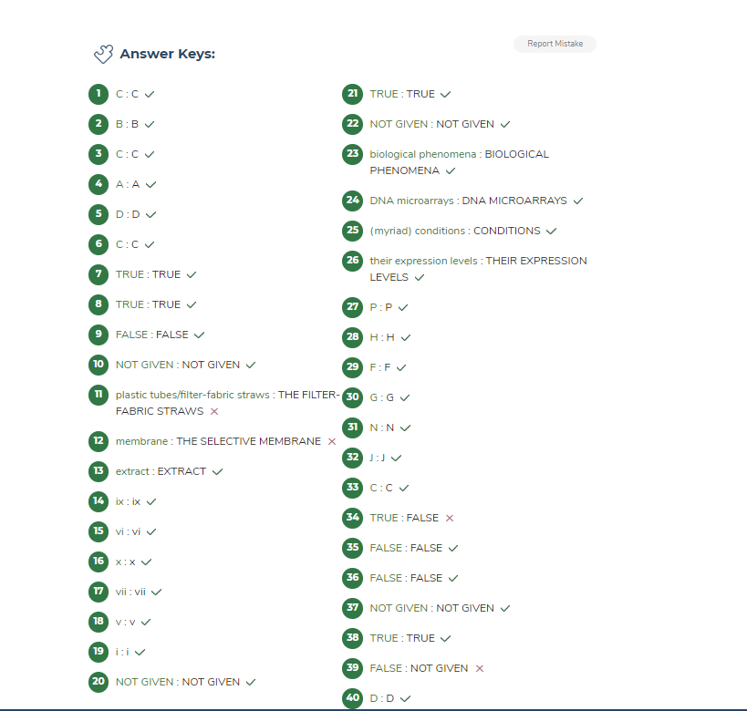

**https://ieltsonlinetests.com/ielts-mock-test-2023-february-reading-practice-test-1**

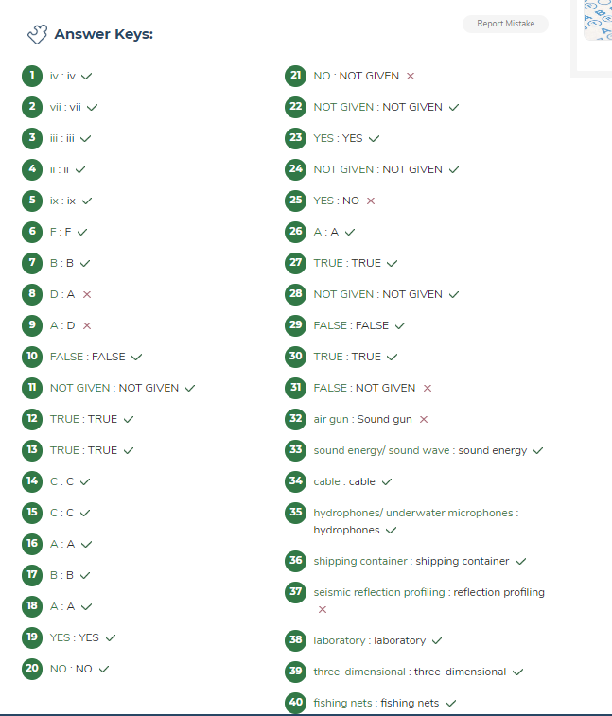

<https://ieltsonlinetests.com/prepare-ielts-general-training-volume-1-writing-practice-test-1>

Your friend is thinking about learning to drive and would like some advice.

Write a letter to your friend. In your letter

• say why a driving licence is advantageous

• recommend a driving school

• give any extra guidance/tips

Dear Nirav,

Hi there! Hope you are doing well and all your family are doing well too. I am also fine despite of some hard work. I’m delighted to know you are going to learn driving. Ever since you asked me for my opinion about driving, I’ve been kicking around the matter before writing this letter.

Driving license is advantageous as it allows you to drive a car in a particular country legally. Moreover, you are no longer dependent on others for transportation and travel at your convenience. Regarding driving schools, I would recommend Rainbow Driving Center. They are known for their professional and patient instructors who are experienced in teaching people of all skill levels. They also have a flexible schedule that can accommodate your work schedule. It is also essential to look for a driving school that is certified and licensed by the government. Keep your focus on the road, and don’t let distractions get in the way. Always follow traffic rules and regulations including wearing a seatbelts. Finally, be sure to get enough rest before driving, as fatigue can impair your driving ability.

Learning to drive can be a great experience and I wish you the best of luck in your endeavors. If you have any questions or need any further guidance, don’t hesitate to reach out to me.

best regards,

Hemant Chandani

**[226 Words]**

<https://ieltsonlinetests.com/prepare-ielts-general-training-volume-1-writing-practice-test-2>

Should long-term job seekers in receipt of government benefits be made to do voluntary work so that they give something back to the community? Give reasons for your answer and include any relevant examples from your own knowledge or experience.

Volunteering is a way through which a person can provide his services to this community. There are numerous people who show their keen interest to participate in these kinds of services. However, those who are appointed by the government should also have to take an initiative to do voluntary tasks.

The first reason why I think such services are needed is because of the favourable environment which governments provide to these jobseekers. For example, many governments provide free education at least till secondary level. Similarly, universities run by the state provide their students with stipends or scholarships. On top of that, new job opportunities are created every year. Thus, to mould a qualified employee, governments must spend an exorbitant amount. Secondly, the person must be grateful that he or she is receiving government support in / during hard pinching times. To return the favour, they should offer service to the society / the government. The main advantage is that volunteering gives job seekers an opportunity to acquire crucial job skills. For example, In Switzerland, which has saved a staggering 44 million pounds after it started working for benefit programs for the out of work adults. The money saved was used to provide free education to orphan children.

Additionally, Citizens receiving governmental perks are needed to realise the fact the services rendered by them without any payment will assist myriad communities. For example, Free rations by various officials during the time of the Covid-19 pandemic proved very helpful to needy persons. Steps like these are needed to practise more to pay back the country. By doing this a country can lead and achieve progress and development for all rather it is the richer section or the poor. In my opinion, many people of higher authority, notwithstanding their work, are trying in every aspect to help and participate intriguingly. They play a crucial role in every sector and department.

To conclude, the government job-seekers nonetheless of their work and earnings, are jubilant to give their time in giving the best back something in Public. In the future, the government delightfully aims for the development of the country

**[355 Words]**

https://ieltsonlinetests.com/ielts-mock-test-2023-february-listening-practice-test-3

